Network Task

1)Get me the IP address of a particular domain (guvi.in). How do I find my CPU/memory usage of my server?. Test the connectivity between 2 nodes?

To get the IP address on the domain – guvi.in
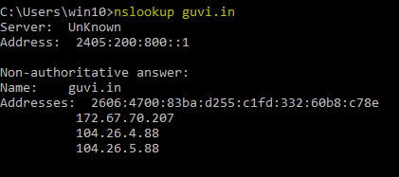
To get the CPU/memory usage of the server we need to use “top” command which will gives the CPU/memory usage of the server.
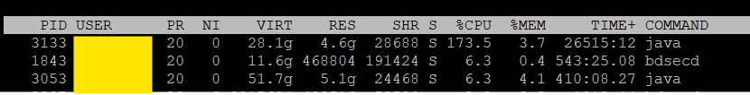
Test the connectivity between 2 nodes we need to use “ping” command.
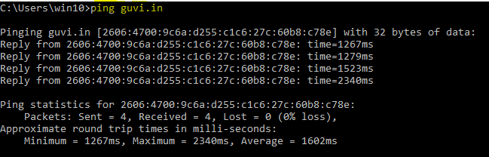

2) I have deployed an application in guvi.com:9000, and logs show my app is running, but I’m unable to view the page. Check whether my port is open or not ?

The mentioned port 9000 is not open and the guvi.com:9000 is not reachable.
